Measurements and Filtering for Position and Velocity for Satellites in Close Proximity Operations

Robert B. Scheible[1]

Virginia Polytechnic Institute and State University, Blacksburg, VA, 24060

# Nomenclature

*A* = state transition matrix

*B* = control input model

*u*= control vector

*P* = state covariance matrix

*Q* = process noise covariance

*R* = measurement noise covariance

*H* = measurement map matrix

d*t* = time step

*t* = time

***x*** = state

# Introduction

T

HIS paper is a continuation of work on Optimal Constrained Relative Station Keeping for Small Satellites by Ian Elliott, Kristen Tetreault, and Jonathon Black. Their paper assumed perfect knowledge of target and chaser position for use in the Clohessy-Wiltshire equations, and used that to calculate the optimal maximum amount of time the chaser could maintain station keeping. This paper works to apply simulated measurements to the true state, and use a Kalman filter to find a more accurate estimate of the state.

# Measurement Simulation

A brief study of different possible sensor systems was conducted. Ultimately a combination of camera tracking system and a laser range-finder were used to find direction and range, respectively. A phased-array radar system was considered, and may be explored in later research; however, the size of current systems is prohibitive.

The laser-rangefinder the MATLAB simulation uses is a FLIR MLR1001. The data sheet cites a range from near 0 cm to over 100 m, and a resolution under 0.2 m1. For the purposes of the MATLAB simulation, the measured range is found by taking the true range, adding a random Gaussian-distributed error with a standard deviation of 0.0255, and rounding to the closest 0.2 m increment. The standard deviation of 0.0255 provides a 95% confidence bound of 0.1 m.

A camera tracking system would be used to find the direction of the target. This simulation is very simplistic; the camera can track the target in all conditions, and does not simulate target acquisition. The tracking camera is assumed to have an order of magnitude more error than the star tracker; 60 arc seconds 1-sigma bore sight accuracy, and 400 arc seconds 1-sigma roll axis accuracy. These values are based off of the Blue Canyon Nano Star Tracker2.

# Kalman Filter

A Kalman filter was used to reduce the error and estimate the position. The state was the relative position and relative velocity.

$$x=\left[\begin{matrix}\begin{matrix}x \\ y \\ z\end{matrix} \\ \begin{matrix}\dot{x} \\ \dot{y} \\ \dot{z}\end{matrix}\end{matrix}\right]$$

The initial estimated relative position was the true value; 30 m in the x direction, 0 m in both the y and z direction. The initial estimated relative velocity was 0 m/s; although the true value had a slight drift, 0.01 m/s, in the z direction.

The state transition matrix was a simple propagation using Euler’s method. As the simulation itself propagates with Euler’s method, a more robust system model causes unnecessary drift.

$$A=\left[\begin{matrix}\begin{matrix}1 & 0 & 0 \\ 0 & 1 & 0 \\ 0 & 0 & 1\end{matrix} & \begin{matrix}∂t & 0 & 0 \\ 0 & ∂t & 0 \\ 0 & 0 & ∂t\end{matrix} \\ \begin{matrix}0 & 0 & 0 \\ 0 & 0 & 0 \\ 0 & 0 & 0\end{matrix} & \begin{matrix}1 & 0 & 0 \\ 0 & 1 & 0 \\ 0 & 0 & 1\end{matrix}\end{matrix}\right]$$

The acceleration is accounted for as a control-input **u**, containing both the thrust of the spacecraft and the calculated HCW accelerations. The control-input model uses Euler’s method to update the state, so position is not affected by acceleration.

$$B=\left[\begin{matrix}\begin{matrix}0 & 0 & 0 \\ 0 & 0 & 0 \\ 0 & 0 & 0\end{matrix} \\ \begin{matrix}∂t & 0 & 0 \\ 0 & ∂t & 0 \\ 0 & 0 & ∂t\end{matrix}\end{matrix}\right], u=\left[\begin{matrix}\ddot{x} \\ \ddot{y} \\ \ddot{z}\end{matrix}\right]$$

A Montecarlo simulation was used to find information on the performance of the Kalman filter. The simulation output the root mean squared error of the estimated position, giving a single number to tune the filter with. The state covariance matrix ***P***, process covariance matrix ***Q***, and measurement covariance matrix ***R,*** are identity matrices multiplied by a single value. The filter was tuned by testing six possibilities for each value, ranging from 10-1 to 10-6, by order of magnitude. This resulted in the following matrices, with a root mean squared error of 44.7854 over 2000 data points.

$$P={10}^{-4}*I\left(6\right),Q={10}^{-3}*I\left(6\right),R={10}^{-1}*I\left(3\right)$$

Where ***I*** is the identity matrix. The equations for the Kalman filter can be found in section 3.3.1 of reference 3.

# Results

The results for the position error in a Montecarlo simulation of 1000 runs can be seen in Figures 1, 2, and 3. The Kalman filter clearly reduces error across the board; however, there is an initial discrepancy in the z-position due to assuming an incorrect initial z velocity (Fig. 3). The maximum 95% confidence bound for any estimate error is about 0.08 meters. As the simulation has a safety buffer of 0.5 meters, this is well within the acceptable range. Even without using a filter at all, the maximum measurement error is 0.1 meters, leaving a factor of safety of 5. The filter reduces the error to about 0.02 meters for x, about 0.001 meters for y, and about 0.001 meters for z as well.

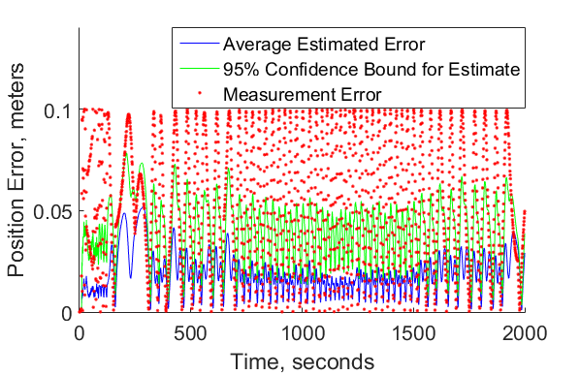

*Figure 1: x Position Error*

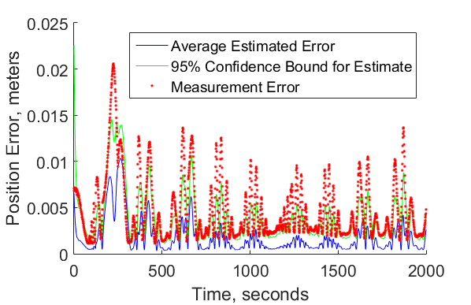

Figure 2: y Position Error

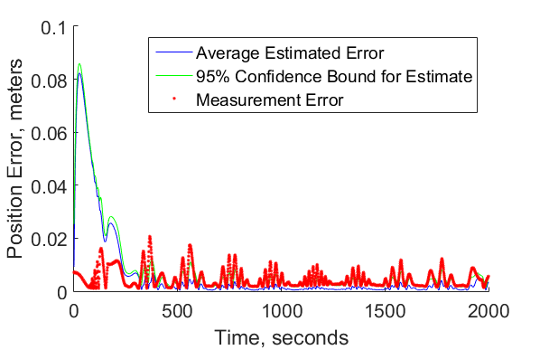

Figure 3: z Position Error

# Further Work

The next step in this work is to integrate the Kalman filter results into the control system, so the needed thrusts are generated using the expected values instead of the true values. This will allow for a more expansive study of the error induced by the measurement systems. It would also be possible to make a more robust simulation, using an ODE solver rather than Euler’s method. With a more accurate simulation, it would be worthwhile to compare the linear Kalman filter to an extended Kalman filter, or other filtering algorithms.

# References

1“MLR100 Miniature Laser Rangefinder/Altimeter,” *FLIR Systems*, URL: <http://cvs.flir.com/mlr100-laser-rangefinder-datasheet> [cited 8 August 2016].

2“Nano Star Trackers,” *Blue Canyon Technologies,* URL: <http://bluecanyontech.com/wp-content/uploads/2016/07/NST.pdf> [cited 8 August 2016].

3Crassidis, J. L., and Junkins, J. L., Optimal *Estimation of Dynamic System*, 2nd ed., CRC Press, New York, Chap. 3.3.1.

1. Undergraduate Research Assistant, Aerospace and Ocean Engineering, Virginia Polytechnic Institute and State University